**Pacman Problem –Easy**

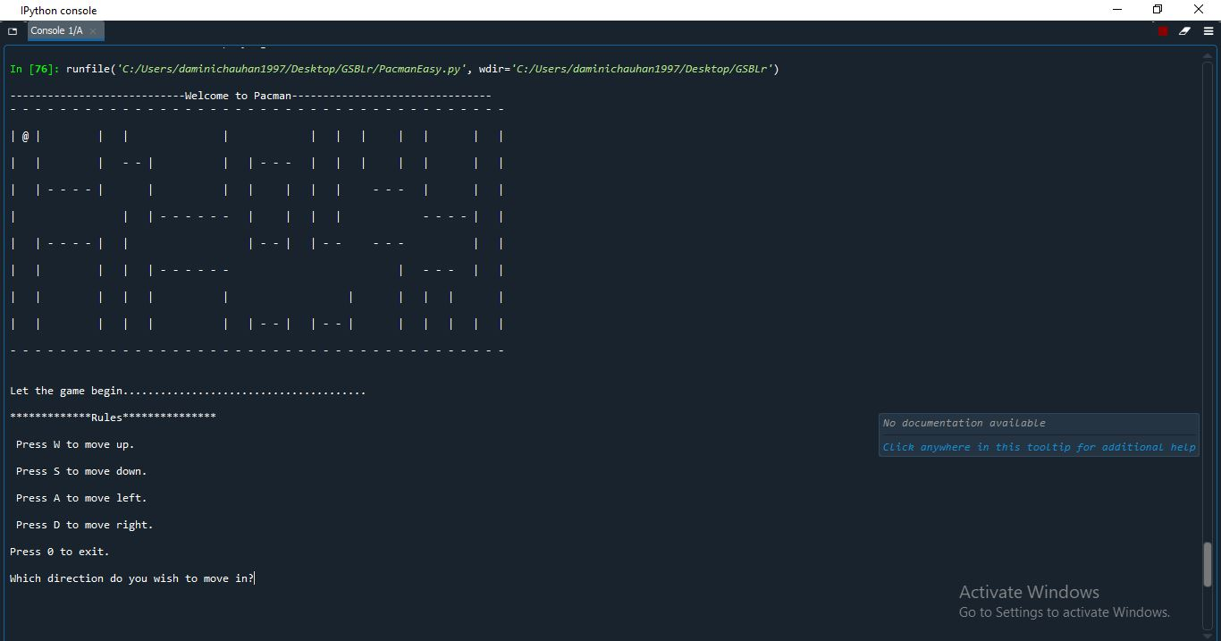

* I have used Python to solve this problem.
* I have majorly used if-else blocks and functions to perform all the operations.